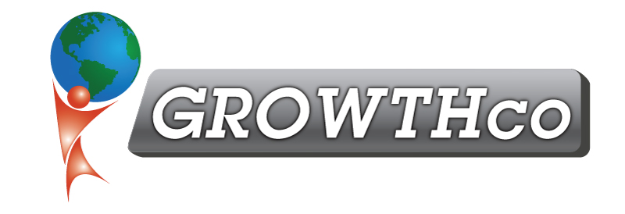
Category:
Lean Thinking

Course Prerequisite:
None

Course Length:
16 hours

Materials:
Included

Cancellation Policy:
Less than 14 days, 50% non-refundable , less than 7 days 100% non-refundable
Minimum Number of Students:
6

Maximum Number of Students:
16

Delivery:
vILT or cILT
(virtual or classroom)

Pre-work:
None

Value Stream Mapping (VSM)

Course Description
Value Stream Mapping (VSM) is a Lean Manufacturing technique used to analyze and design the flow of material and/or information. It enables a company to identify and eliminate waste, in order to streamline work processes, cut lead times, reduce costs, and increase quality.

Through VSM, a team of employees maps the current state from customer back to raw material, including all steps – both value-added and non-value-added – and develops a Future State vision to act as a blueprint for Lean activities. The Future State often represents a significant change from the way the company currently operates, and during VSM, the employee team develops an implementation strategy to make the Future State a reality. The most urgent needs are addressed first and can typically be met in a short time frame when the appropriate resources are applied.

Who Should Attend
This course is designed for those who are new to quality and those who are quality practitioners who work in office and support functions, manufacturing, service, and supply chains.

Learning Objectives
During this Value Stream Mapping course, participants will develop both the theoretical and practical applications of Value Stream Mapping concepts, tools, and techniques, through a combination of classroom instruction and team-based exercises.

