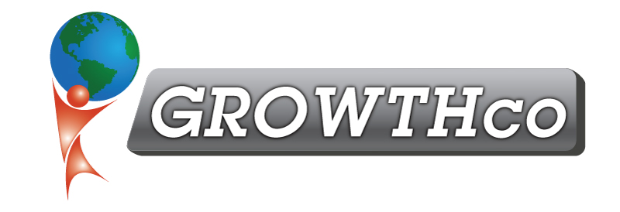
Category:
Process Improvement Tools / Technical Skills

Course Prerequisite:
None

Course Length:
24 hours

Materials:
Included

Cancellation Policy:
Less than 14 days, 50% non-refundable , less than 7 days 100% non-refundable
Minimum Number of Students:
6

Maximum Number of Students:
16

Delivery:
vILT or cILT
(virtual or classroom)

Pre-work:
None

Kaizen Events

Course Description
Kaizen Events (also known as Kaikaku, Kaizen Blitz, Kaizen Burst, Gemba Kaizen) are focused, intense and short-term projects in which a cross-functional team makes rapid improvements in a short period of time. Kaizen Events normally takes 3 to 10 days and the intensity and urgency overcomes the intellectual resistance to a new paradigm as people have little time to think of reasons for delay. It is common to completely re-engineer a process in a Kaizen Event week.

Kaizen Event benefits include:

- Streamlined processes
- Reduced waste and/or non-value add activities
- Reduced cycle time
- Reduced cost of operations
- Removes bottlenecks
- Improved throughput
- Improved customer satisfaction
- Improved productivity

Who Should Attend
This course is designed for wide range of participants, including process owners, supervisors, managers, and leaders within an organization who will be responsible for process improvement initiatives. It is also appropriate for employees who are not confident about continuous improvement and will help build their confidence to embark on other continuous improvement projects.

Learning Objectives
Participants in Kaizen Events training program will learn:

- How Process Charts streamline workflow
- How to establish TAKT time, process time, and setup time.
- How to determine the right people to include in initiatives
- How to measure performance and use metrics
- How to balance work for the people involved
- How to design a Kanban system
- 5-S and how to organize for productivity

