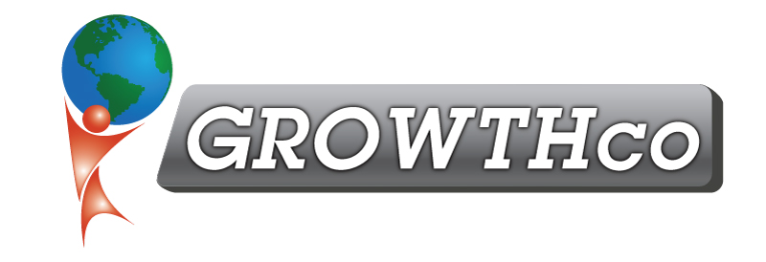
Category:
Essential Skills

Course Prerequisite:
None

Course Length:
12 hours

Materials:
Included (digitally only)

Cancellation Policy:
Less than 14 days, 50% non-refundable , less than 7 days 100% non-refundable
Minimum Number of Students:
4

Maximum Number of Students:
20

Delivery:
vILT or cILT
(virtual or classroom)

Pre-work:
None

Effective Communications is a hands-on training that has employees learning and practicing the techniques and models of effective communications.
Communications: Effective Communications

Each employee will take self-assessments and identify their strengths, weaknesses, and specific social style (Driving, Expressive, Amiable, or Analytical). They will understand how to identify and adapt to other people's social style to maximize the effectiveness of their communications.

Topics include:
- Definition of Communications
- All forms of Verbal & Non-Verbal Communications
- Effective Listening
- Reading Body Language
- Active Listening Skills
- Reflective Listening Skills
- Open-Ended Question Asking
- Asking Clarifying Questions
- Email Effectiveness
- Social Styles Assessment & Workshop
- Feedback
- Team Communications & Barriers to Effective Communications
- Departmental Tours to better understand all departments

What situations do you find it most difficult to communicate?
Is it when giving feedback, critiquing others, or dealing with a lack of performance issue?
How about when you think your manager or supervisor is wrong? In this classroom-based, adult learning environment, participants practice techniques and tactics learned using their real-world situations in a safe training environment.

