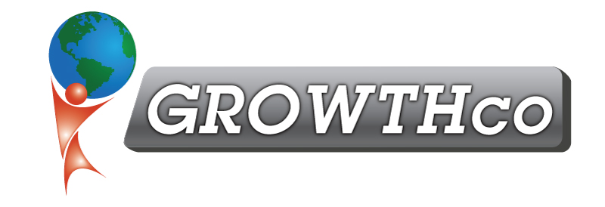
Conflict Management

Category:
Communications

Course Prerequisite:
none

Course Length:
8 hours

Materials:
Included (digital only)

Cancellation Policy:
Less than 14 days, 50% non-refundable , less than 7 days 100% non-refundable
Minimum Number of Students:
4

Maximum Number of Students:
15

Delivery:
vILT or cILT
(virtual or classroom)

Pre-work:
None

Description:
Conflict management is the process of limiting the negative aspects of conflict while increasing the positive aspects of conflict. The aim of conflict management is to enhance learning and group outcomes, including effectiveness or performance in organizational setting. Properly managed conflict can improve group outcomes.

Conflict is inevitable, especially when work teams are diverse and stress levels are high. Conflict results from:
- Poor Relationships
- Externals & Moods
- Ineffective Structure
- Varying Interests
- Opposing Values
- Improper Data

The class instructor leads participants through a series of exercises and facilitated discussions to develop an understanding of how to achieve better results.

Course Benefits:

- How to disagree without hurting relationships
- Understanding of what contributes and ignites disagreement and conflict and the nature of people’s reactions
- Learn the skill set for helping people through conflict
- Understanding as a leader how to react to conflict
- Furlong’s Circle of Conflict
- Thomas-Kilmann Conflict Modes (Competing, Collaborating, Compromising, Avoiding, & Accommodating)
- Emotions & Stress Management with Coping Strategies
- 5 Levels of Conflict – Lyssa Adkins & Michael Spayd
- “Clearing the AIRR” model to resolve conflict
- WTF: It’s not what you think!
- Activities to use in teams to understand conflict better

